Google login:
aiimquestions@gmail.com
yuyang1234567
sites.google.com/view/aiimprogram

https://docs.google.com/forms/d/1qzijxcXiMVphM_z7D1bXobO7AzAUEskpLi0Y1GCC1eY/edit?pli=1

AIIM - Artificial Intelligence Integration in Machines
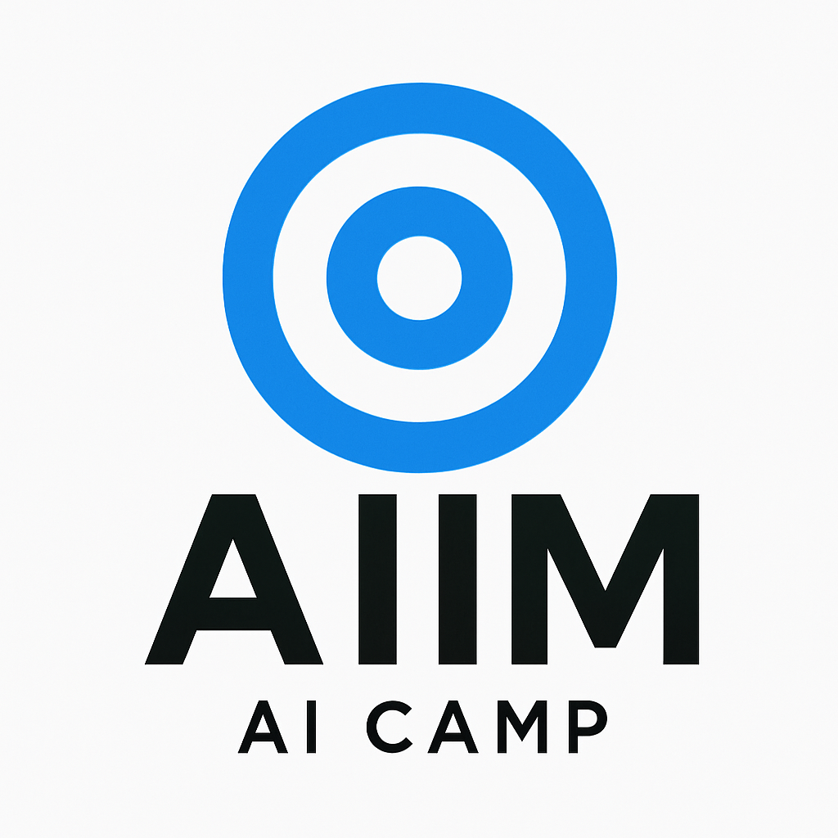

August 1st - August 10th

Deadlines:
Marketing done: June 12th
Projects Complete July 11th
Informational Session: July 12th

Projects:

Impressive One:
-Little robot that can follow voices and use a camera to identify common objects
-Recognize who's talking to it?

Student Project Example:
-Robot arm that can detect if something is trash or recycling and place it in appropriate bin.

Camp Synopsis:
Students will either make groups or work individually on a project to present at the end of camp, with mentor help throughout the whole process.

Camp Schedule:

Date | Plan | Deliverables
8/1 (Skippable) | -Introduction, quick ice breaker  -Lecture: Introduction to coding and Fusion 101
8/2 | -Lecture: Neural Networks, CNNS (Convolutional Neural Networks) and CAD recycling robot  -Brainstorm for project
8/3 | -Finish fusion lecture  -Project plan | -Finish Fusion CAD
8/4 | -Work Day | -Finished Project Proposal
8/5 | -Work Day | -Finish CAD
8/6 | -Work Day
8/7 | -Work Day
8/8 | -Work Day
8/9 | -Work Day | Finalized Project with slides?
8/10 | -Work Day

